**1. What is an Android Manifest file, and why is it important in Android application**

**development?**

Ans :-

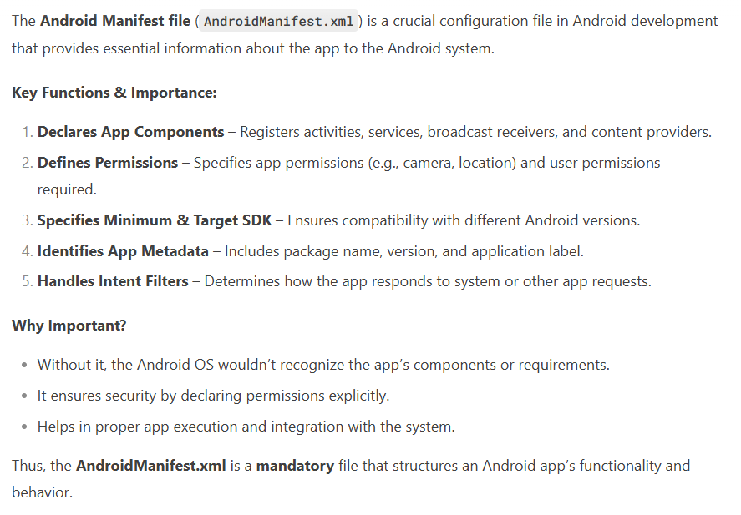

**above manifest file details given in ppt(must refer it).**

1. **Describe the steps to edit an Android Manifest file to change the application's theme.**

Ans :-

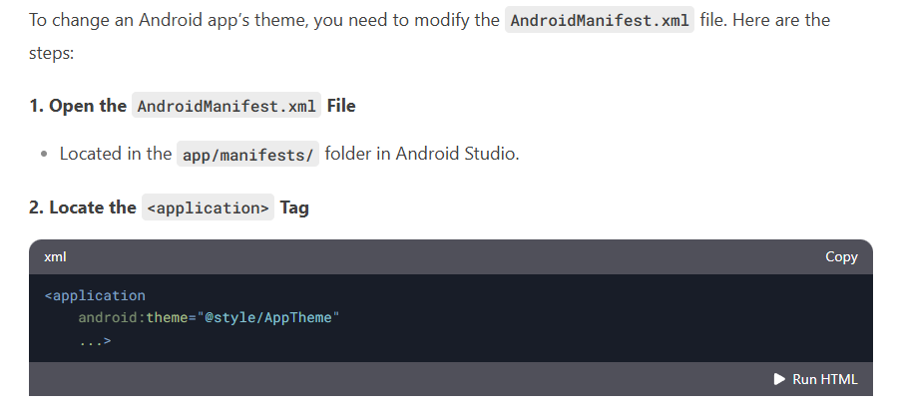

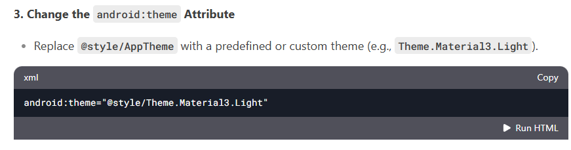

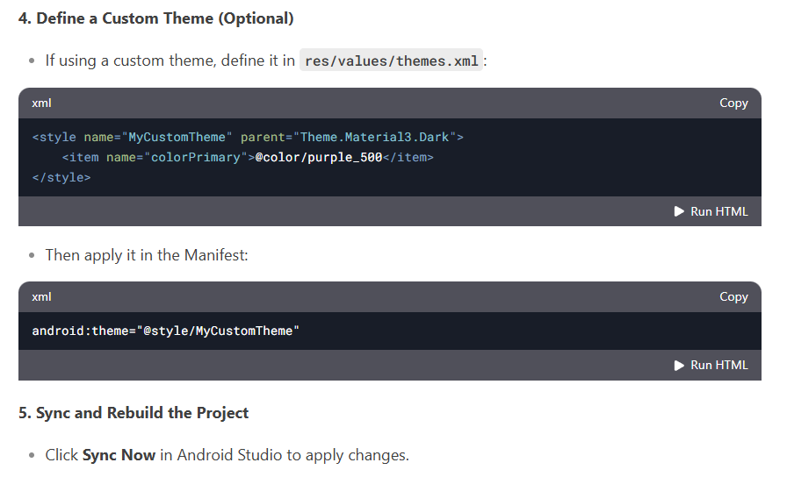

1. **How does the Android Manifest file help in managing an application’s identity? Provide an example.**

Ans :-

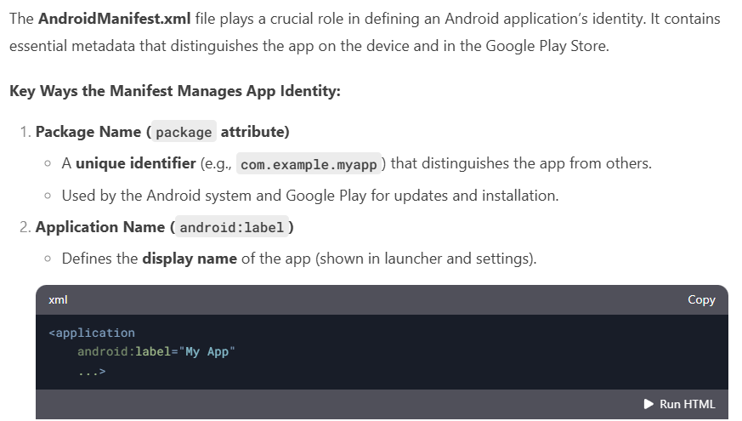

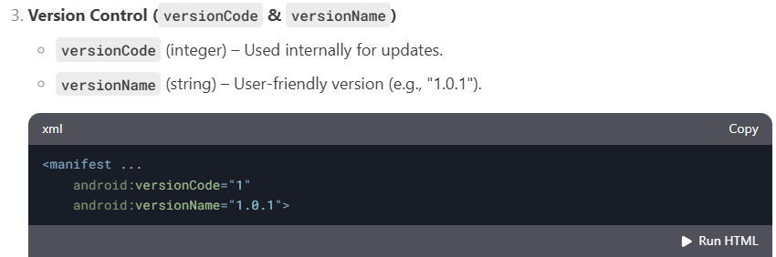

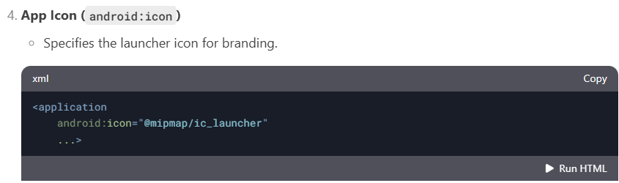

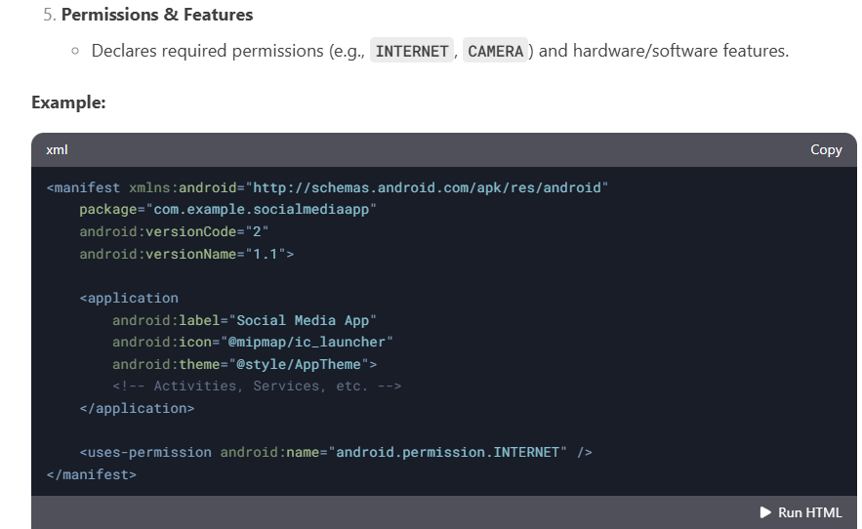

1. **What are the system requirements you can enforce using the Android Manifest file? Explain with at least two examples.**

Ans :-

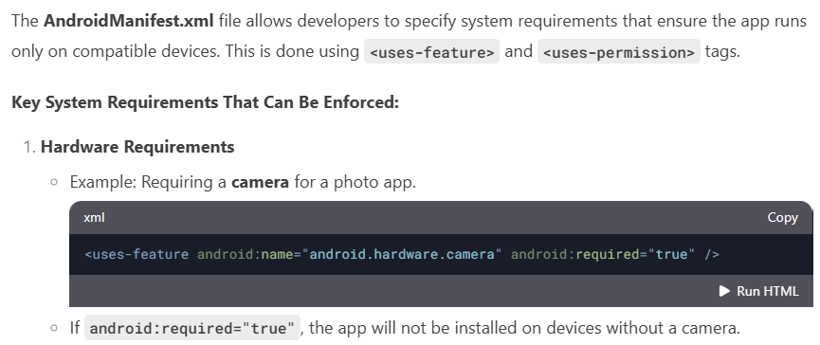

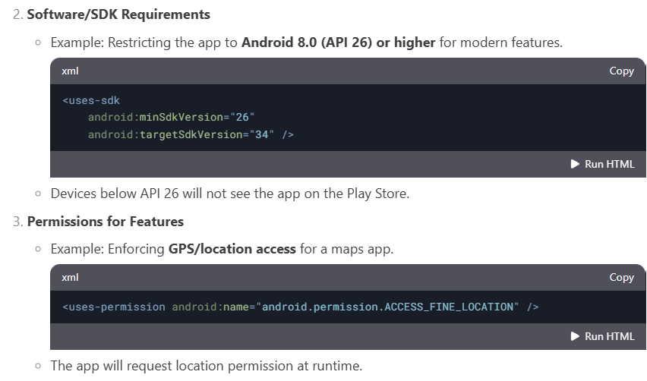

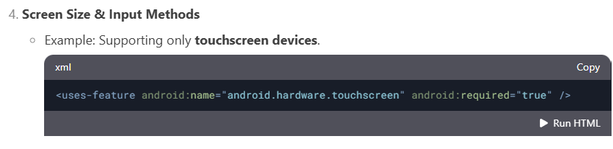

1. **How do you register activities and other application components in the Android Manifest file? Provide a sample XML snippet.**

Ans :-

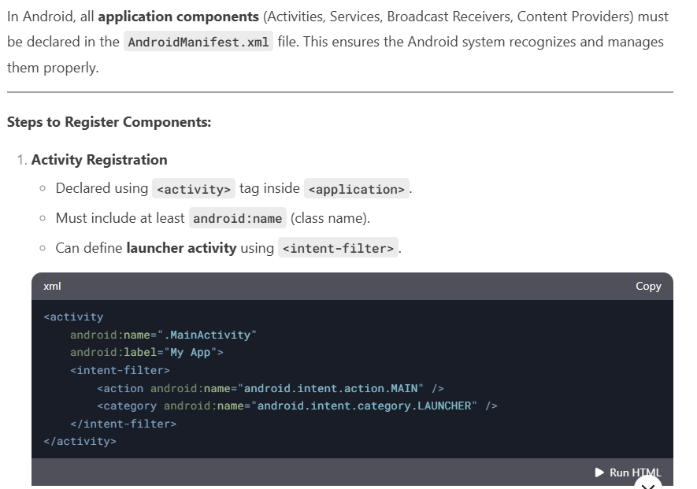

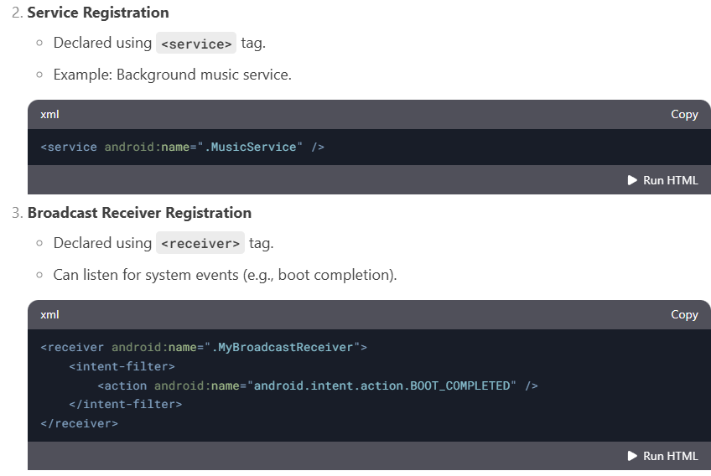

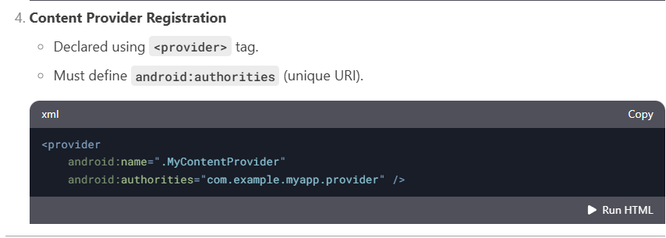

1. **Explain the role of the "android:versionCode" and "android:versionName" attributes in the Android Manifest file.**

Ans :-

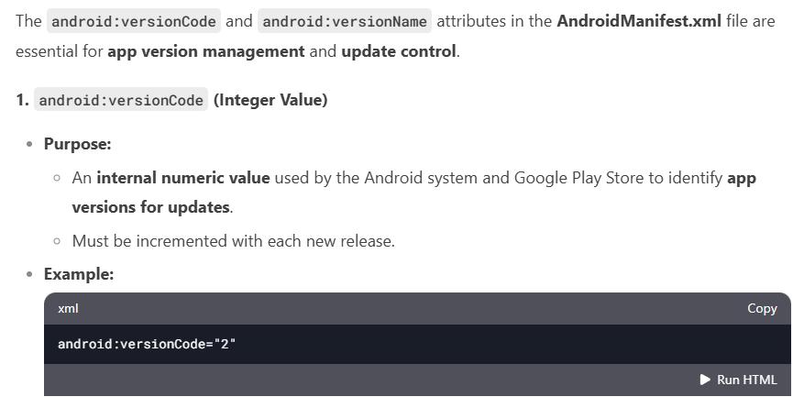

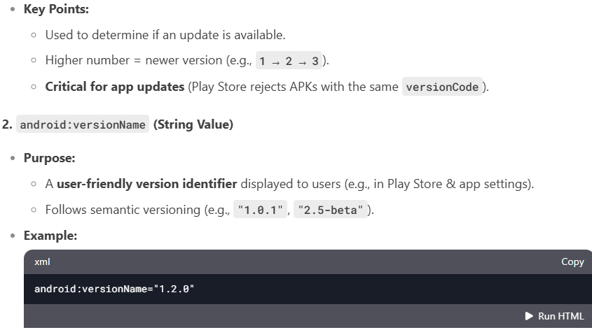

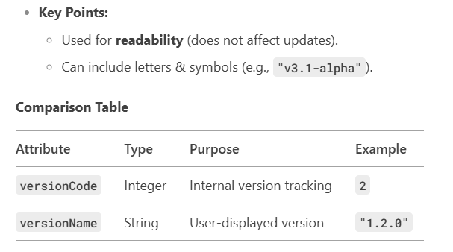

1. **Describe how to declare permissions in the Android Manifest file. Provide an example of requesting a permission for internet access.**

Ans :-

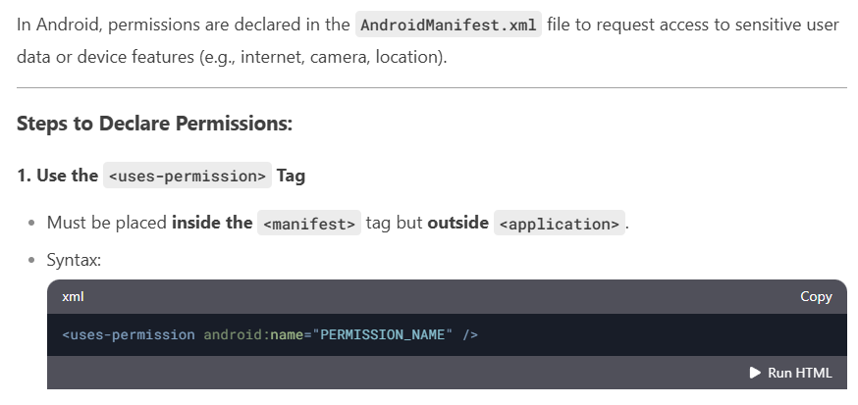

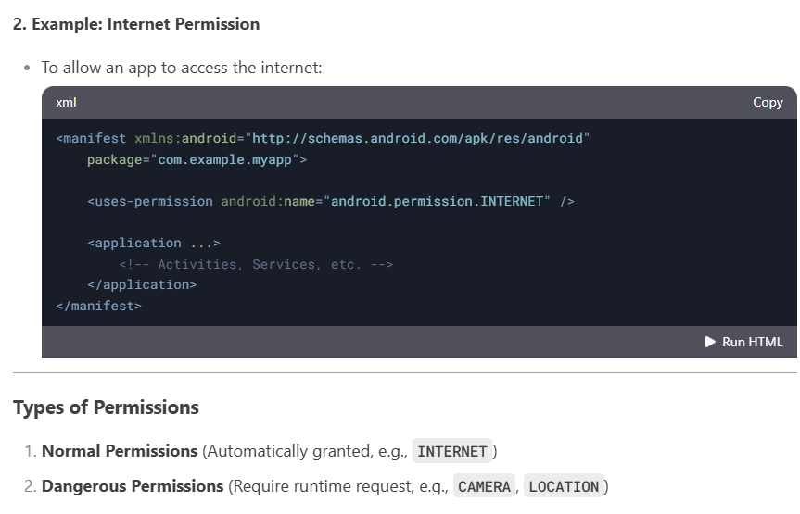

**8.What is the purpose of the <uses-feature> element in the Android Manifest file? Give an example of how to use it.**

Ans :-

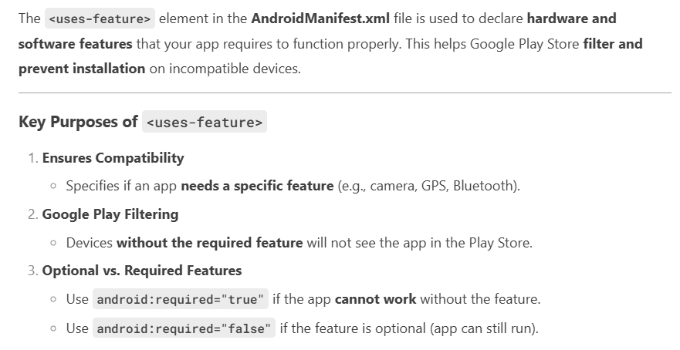

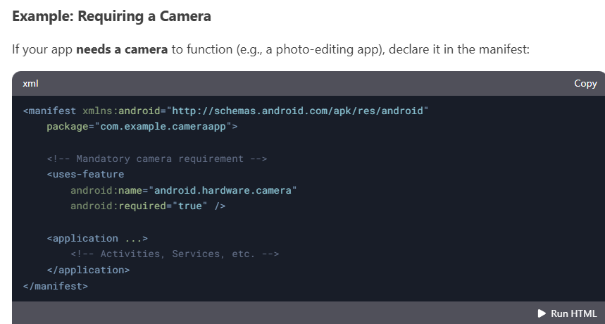

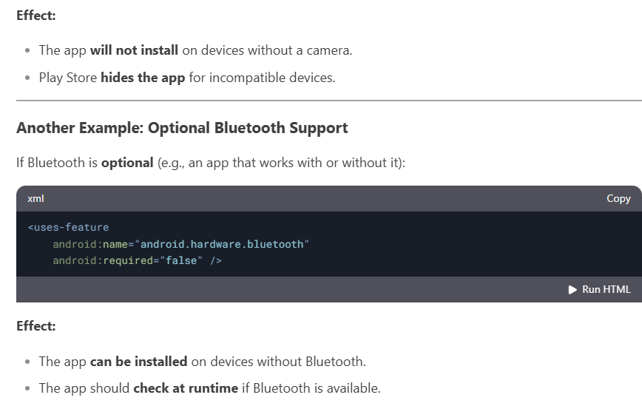

**9.How can you specify the minimum and target SDK versions for your application in the Android Manifest file? Why is this important?**

Ans :-

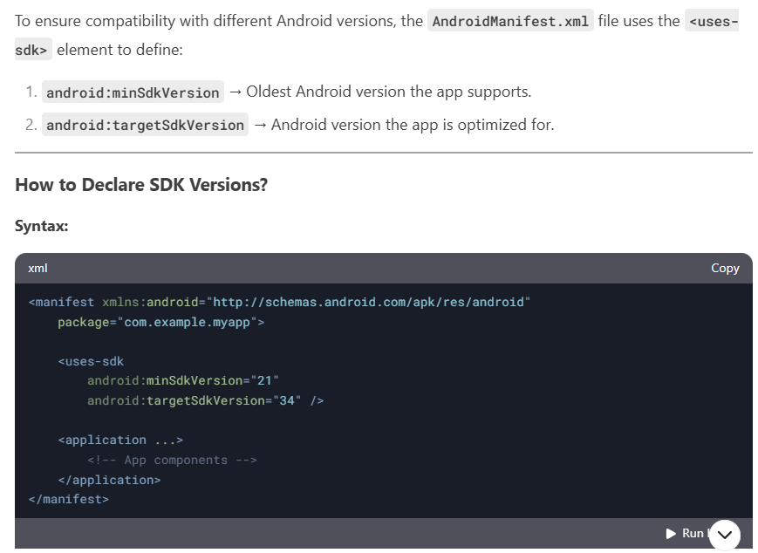

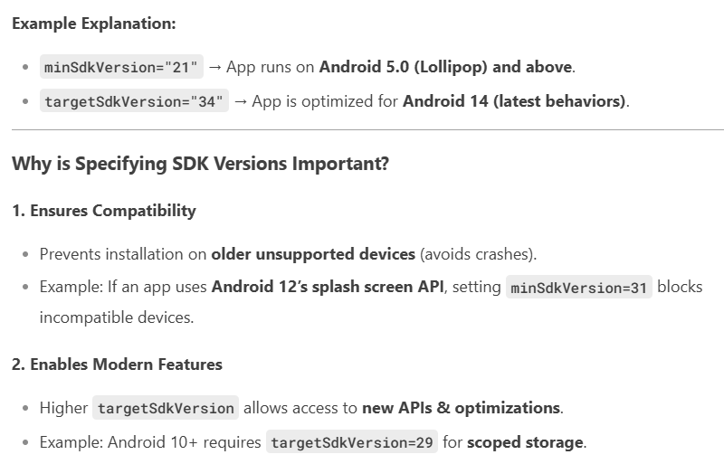

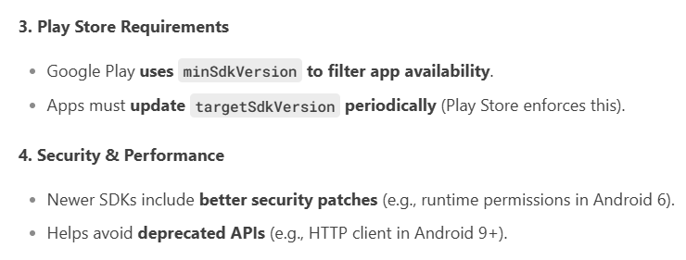

1. **Discuss the importance of managing permissions in Android applications and how you can handle runtime permissions in your code.**

Ans :-

